33.48: a) For light in air incident on a parallel-faced plate, Snell’s Law yields:
b) Adding more plates just adds extra steps in the middle of the above equation that always cancel out. The requirement of parallel faces ensures that the angle 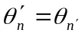 and the chain of equations can continue.
c) The lateral displacement of the beam can be calculated using geometry:
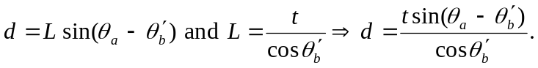
d) 